AD9910 eval TEST

AD9910/PCBZ

**- Written by: jhjeong32snu -**

[jhjeong32@snu.ac.kr](mailto:jhjeong32@snu.ac.kr)

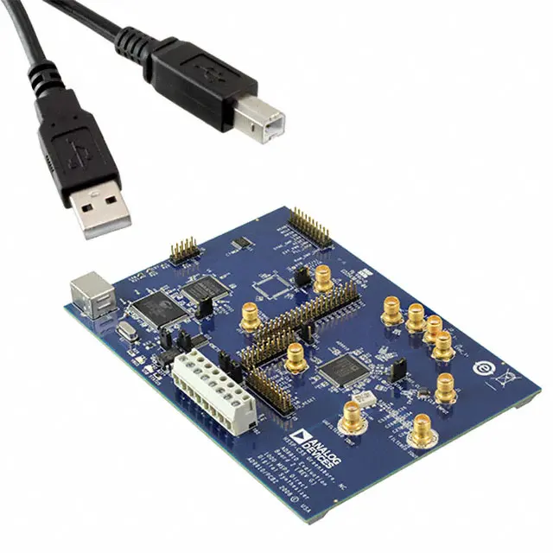

# Contents

**Contents** **2**

**Background** **3**

AD9910 3

Theory of Operation 3

Additional Features 5

Evaluation Board 7

Model 7

Features 7

Basic Diagram 8

Connectors and Biasing 8

Clock Oscillator Option 8

Jumpers 8

Evaluation Board Layout 9

**Theory** **10**

Reference 10

DDS (Direct Digital Synthesis) 11

PLL (Phase Locked Loop) 13

**Procedure** **14**

Evaluation Board software 14

Circuit 16

**Log** **18**

YYYY.MM.DD 19

2020.02.04 20

2020.02.06 24

2020.02.12 27

2020.02.14 28

# Background

## **AD9910**

### Theory of Operation

* + - Single Tone Mode
      * DDS signal control parameters are supplied directly from the programming registers.
      * Eight profile registers are available
        + Each profile is independently accessible
        + Three external profile pins (PROFILE[2:0])
        + A change with the next rising edge on SYNC_CLK

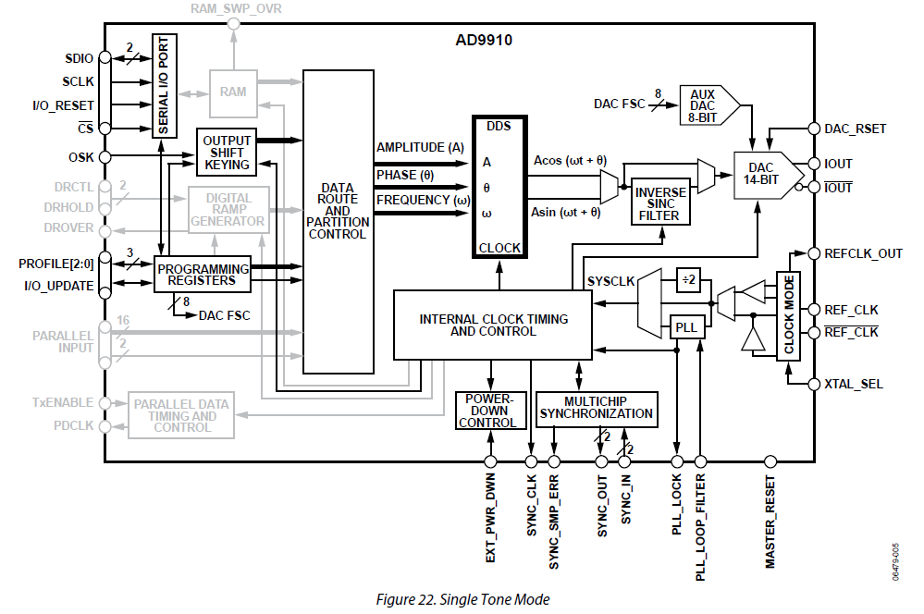

* + - RAM Modulation Mode
      * Activated via the RAM enable bit and assertion of the I/O_UPDATE pin
      * The modulated DDS signal control parameters are supplied directly from RAM
      * The RAM
        + Consists of 32-bit words and 1024 words depth.
        + Provides a very flexible method for generating arbitrary, time dependent waveforms.
        + Programmable through eight independent RAM profile registers

Select a particular profile using the three external profile pins (PROFILE[2:0])

A change will be with the next rising edge on SYNC_CLK

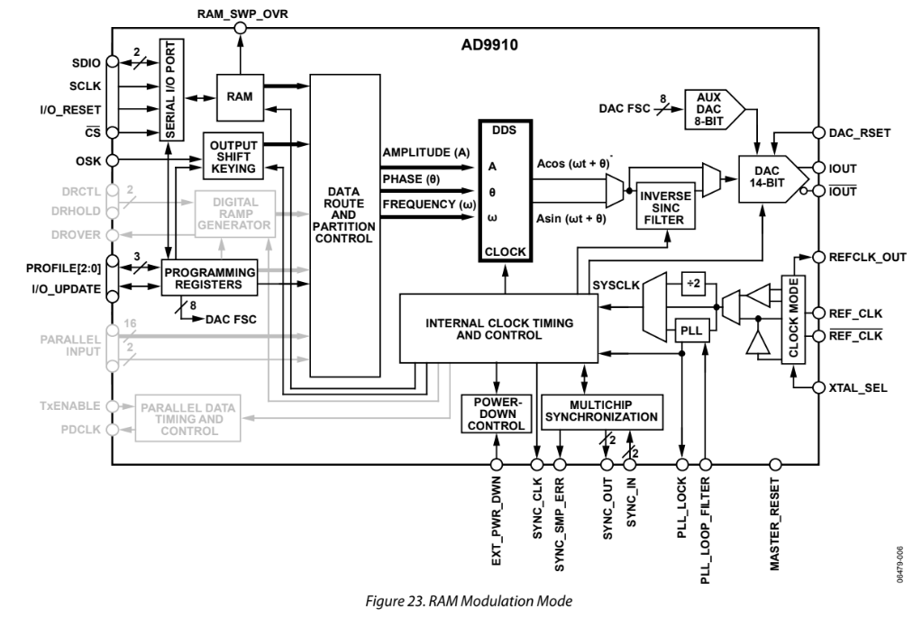

* + - Digital Ramp Modulation Mode
      * a
    - Parallel Data Port Modulation Mode
      * The DDS signal control parameters are supplied from the 18-bit parallel data port
      * The data port is partitioned into two sections
        + The 16 MSBs make up a 16-bit data-word (D[15:0])
        + The two LSBs make up a 2-bit destination word (F[1:0])

The destination word defines how the 16-bit data-word is applied to the DDS signal control parameters

* + - * When the destination bits indicate that the data-word is destined as a DDS frequency parameter
        + The 16-bit data-word serves as an offset to the 32-bit frequency tuning word in the FTW register.
        + This means that the 16-bit data-word must somehow be properly aligned with the 32-bit word in the FTW register.

Accomplished by means of the 4-bit FM gain word in the programming registers

* + - * + The FM gain word allows the user to apply a weighting factor to the 16-bit data-word.

**Table 4. Parallel Port Destination Bits**

|  |  |  |  |
| --- | --- | --- | --- |
| **F[1:0]** | **D[15:0]** | **Parameter(s)** | **Comments** |
| 00 | D[15:2] | 14-bit amplitude parameter (unsigned) | Amplitude scales from 0 to 1-2-14.  D[1:0] are not used |
| 01 | D[15:0] | 16-bit phase parameter (unsigned) | Phase offset ranges from 0 to 2π(1-2-16) radians |
| 10 | D[15:0] | 32-bit frequency parameter (unsigned) | The alignment of the 16-bit data-word with the 32-bit frequency parameters is controlled by a 4-bit FM gain word in the programming registers |
| 11 | D[15:8] | 8-bit amplitude  (unsigned) | The MSB of the data-word amplitude aligns with the MSB of the DDS 14-bit amplitude parameter. The six LSBs of the DDS amplitude parameters are assigned from Bits[5:0] of the ASF register. The resulting 14-bit word scales the amplitude from 0 to 1-2-14. |
| D[7:0] | 8-bit phase  (unsigned) | The MSB of the data-word phase aligns with the MSB of the 16-bit phase parameter of  the DDS. The eight LSBs of the DDS phase parameter are assigned from Bits[7:0] of the  POW register. The resulting 16-bit word offsets the phase from 0 to 2(1 − 2−16) radians. |

### Functional Block Detail

* + - Frequency tuning
      * The direct digital synthesizer (DDS) block generates a reference signal
      * The output frequency (*fOUT*) of the AD9910
        + Controlled by the frequency tuning word (FTW)

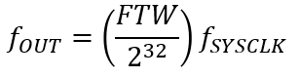

* + - * + Where FTW is a 32-bit integer ranging in value from 0 to 2,147,483,647 (231-1).
      * The FTW required to generate a desired value

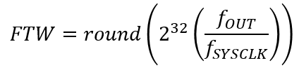

* + - * Programming an FTW greater than 231 produces an aliased image that appears at a frequency given by

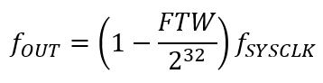

* + - Phase tuning
      * The relative phase of the DDS signal
        + Controlled by means of a 16-bit phase offset word (POW).
        + The relative phase offset (*Δθ*)

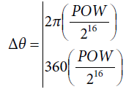

* + - * + Upper quantity - in radian units
        + Lower quantity - in degrees
        + To find the POW value necessary to develop an arbitrary *Δθ*

Solve the previous equation for POW and round the result

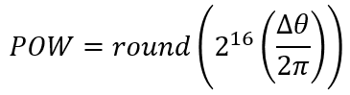

* + - Amplitude tuning
      * The relative amplitude of the DDS signal
        + Digitally scaled (relative to full scale) by means of a 14-bit amplitude scale factor (ASF)

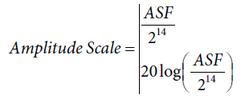

* + - * + Upper quantity - In a fraction of full scale
        + Lower quantity - In decibels relative to full scale.

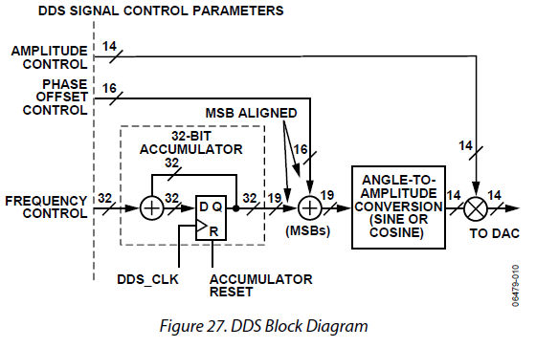

### Additional Features

* + - PROFILES
      * Consist of a group of eight registers containing pertinent operating parameters for a particular operating mode.
      * Parameters are programmed via the serial I/O port.
      * Once programmed
        + A specific profile is activated

By means of three external pins (PROFILE[2:0])

|  |  |
| --- | --- |
| **PROFILE [2:0]** | **Active Profile** |
| 000 | 0 |
| 001 | 1 |
| 010 | 2 |
| 011 | 3 |
| 100 | 4 |
| 101 | 5 |
| 110 | 6 |
| 111 | 7 |

* + - * Two different parameter sets
        + RAM enable = 0

The profile parameters follow the single tone profile format

* + - * + RAM enable = 1

The profile parameters follow the RAM profile format

* + - I/O_UPDATE
      * A pin to transfer data from the serial I/O buffer to the active registers
      * Rising edge on I/O_UPDATE initiates transfer of the register.
      * Alternatively, the transfer of programmed data from the programming registers to the internal hardware can be accomplished by changing the state of the PROFILE[2:0] pins.
    - SYNC_CLK
      * A rising edge active signal
      * Derived from the system clock and a divide-by 4 frequency divider.
    - AUTOMATIC I/O UPDATE
      * This feature is enabled by setting the internal I/O update active bit in Control Function Register 2 (CFR2)
      * When active, the I/O_UPDATE pin becomes an output pin
      * It generates an active high pulse each time an internal I/O update occurs
      * The pulse width is determined
        + By the I/O update rate control bits (CFR2[15:14]).

|  |  |
| --- | --- |
| **I/O Update Rate Control Bits**  **(CFR2[15:14])** | **I/O Update Pulse Width** |
| 00 | 12 SYSCLKs |
| 01 | 24 SYSCLKs |
| 10 | 48 SYSCLKs |
| 11 | 96 SYSCLKs |

* + - * The repetition rate of the internal I/O update is programed
        + Via the serial I/O port
      * Two parameters that control the repetition rate
        + 1. Two I/O update rate control bits in CFR2.
        + 2. 32-bit word in the I/O update rate register that sets the range of an internal counter

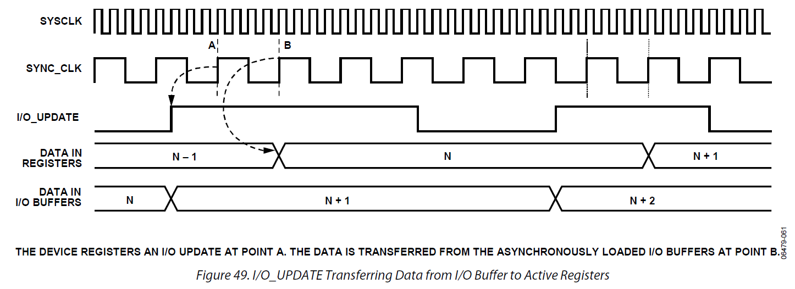



### Serial Programming

* + - Control Interface - Serial I/O
      * Allows read/write access to all registers that configure the AD9910.
      * MSB-first or LSB-first transfer formats are supported.
      * Can be configured as **a single pin input/output (SDIO)** allowing a **2-wire** interface,
      * Can be configured as **two unidirectional pins for input/output (SDIO/SDO)** enabling a **3-wire** interface.
    - General Serial I/O Operation
      * Two phases to a serial communications cycle.
        + **The first** - Instruction phase to write the **instruction byte** into the AD9910.

Contains the **address**

Defines whether the upcoming data transfer is a **write** or **read** operation.

* + - * Write cycle
        + Phase 2 represents the data transfer between the serial port controller to the serial port buffer.
        + **Each bit of data** is registered on **each corresponding rising edge of SCLK**
        + One way to **write** **fewer bytes** than required

By using the **I/O_RESET** pin feature

**I/O_RESET** pin aborts an I/O operation and reset the pointer of the serial port controller.

* + - * + At the completion of any communication cycle

AD9910 serial port controller expects the next eight rising SCLK edges to be the instruction byte for the next communication cycle.

* + - * Read cycle
        + Phase 2 is the same as the write cycle with the following differences

Data is read from the active registers

Data is driven out on the falling edge of SCLK

* + - * + **Note that to read back any profile register** (0x0E to 0x15), **the three external profile pins must be used**

**While this is not required to write to profile registers**

* + - Instruction Byte

|  |  |  |  |  |  |  |  |
| --- | --- | --- | --- | --- | --- | --- | --- |
| **MSB** |  | | | | | | **LSB** |
| **D7** | **D6** | **D5** | **D4** | **D3** | **D2** | **D1** | **D0** |
| R/W | X | X | A4 | A3 | A2 | A1 | A0 |

* + - * R/W - Determines whether a read or write
        + 0: Write
        + 1: Read
      * X, X
        + Bit 5, 6 - don’t care
      * [A4:A0]
        + Determine which register is accessed during the data transfer
    - Serial I/O Port Pin Descriptions
      * SCLK - Serial Clock
        + Used to synchronize data to and from the AD9910
      * CS - Chip Select Bar
        + Active low input that allows more than one device on the same serial communications line
        + If driven high during any communications cycle

The cycle is suspended until CS is reactivated low

* + - * SDIO - Serial Data Input/Output
        + Data is always written on this pin
        + Can be used as a bidirectional data line.
      * SDO - Serial Data Out
        + Data is read from this pin
        + When in single bidirectional I/O mode

Does not output data and set to a high impedance state

* + - * I/O_RESET - Input/Output Reset
        + Active high input on the I/O_RESET pin causes the current communication cycle to abort.
      * I/O_UPDATE - Input/Output Update
        + Initiates the transfer of written data from the I/O port buffer to active register
        + Its pulse width **must be greater than one SYNC_CLK** **period**
    - Serial I/O Timing Diagrams

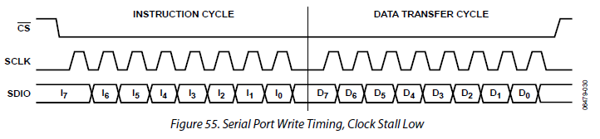

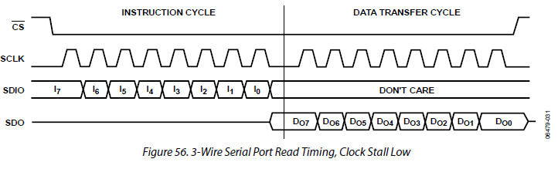

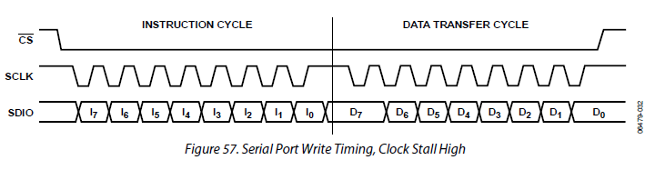

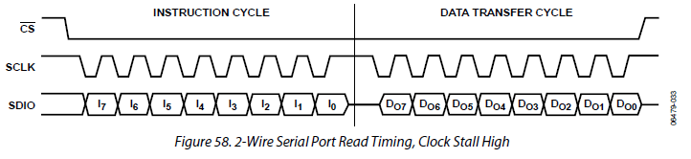

* + - MSB/LSB Transfers
      * The AD9910 serial port can support both most significant bit (MSB) first or least significant bit (LSB) first data formats
      * This functionality is controlled by Bit 0 in Control Function Register 1 (0x00)
      * The default format is MSB first. If LSB first is active, all data, including the instruction byte, must follow LSB-first convention
  + Register Map and Bit Descriptions

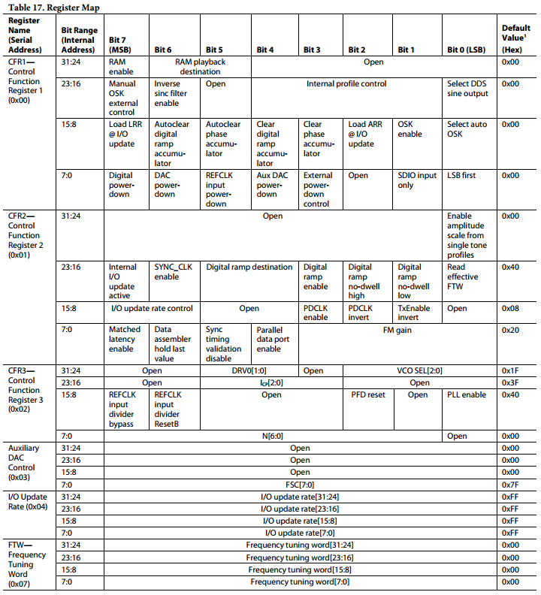

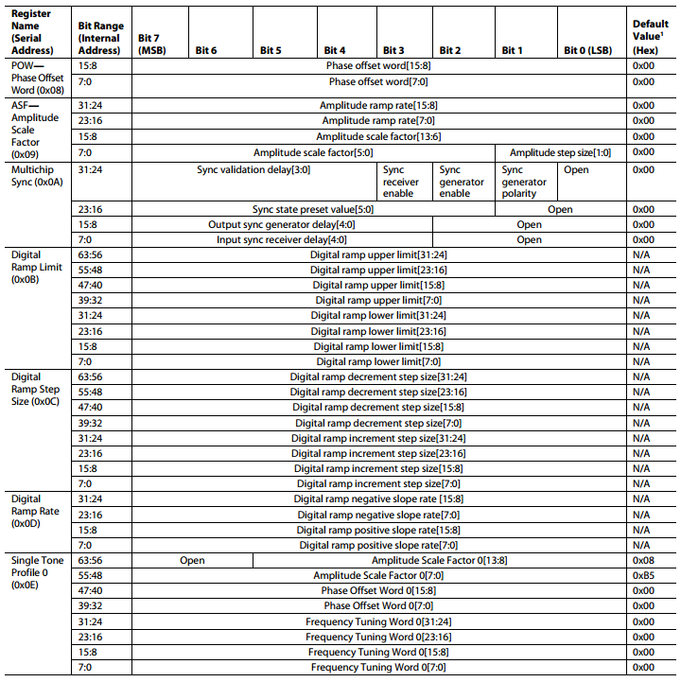

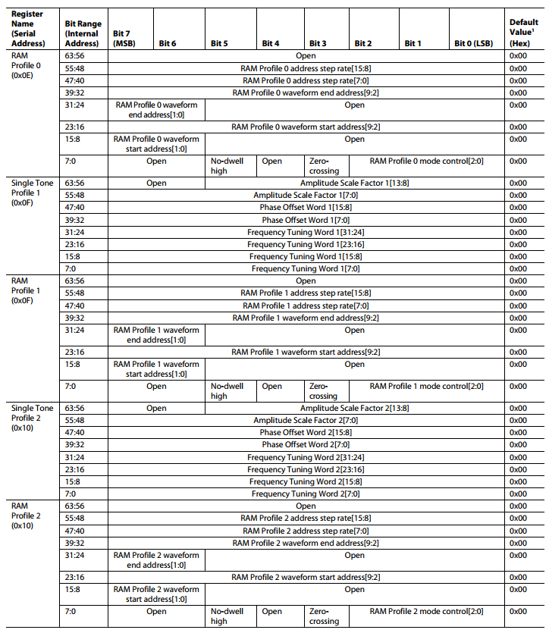

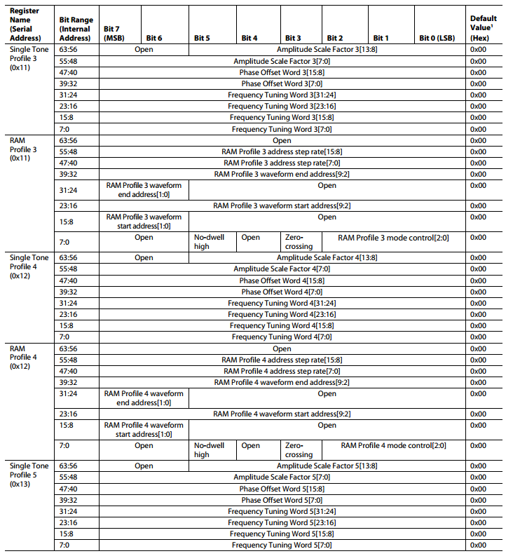

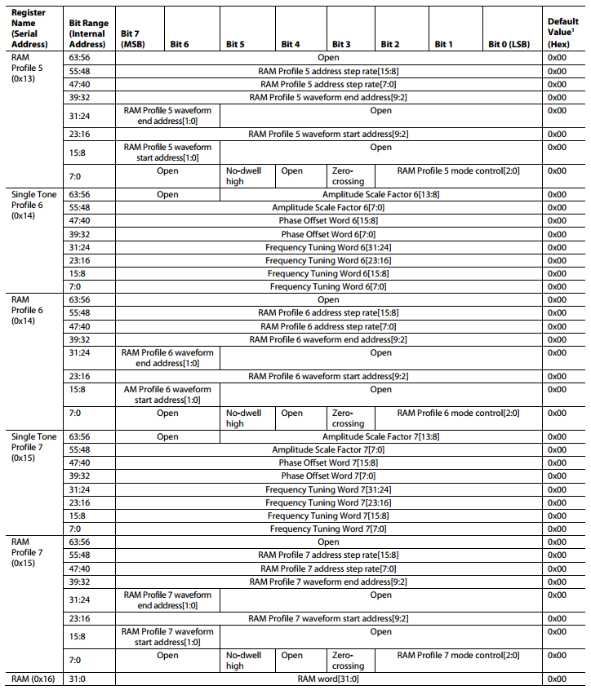

* + - * The serial I/O port registers span an address range of 0 to 23 [A4:A0]
        + 0x00 to 0x16 in **hexadecimal notation**
        + Two of these registers are unused (0x05 and 0x06).

Yielding a total of **22 available registers**

* + - Frequency Tuning Word Register (FTW) - Address 0x07

|  |  |  |
| --- | --- | --- |
| **Bit(s)** | **Mnemonic** | **Description** |
| 31:0 | Frequency tuning word | 32-bit frequency tuning word |

* + - a
    - a

## **Evaluation Board**

### Model

* + - AD9910/PCBZ

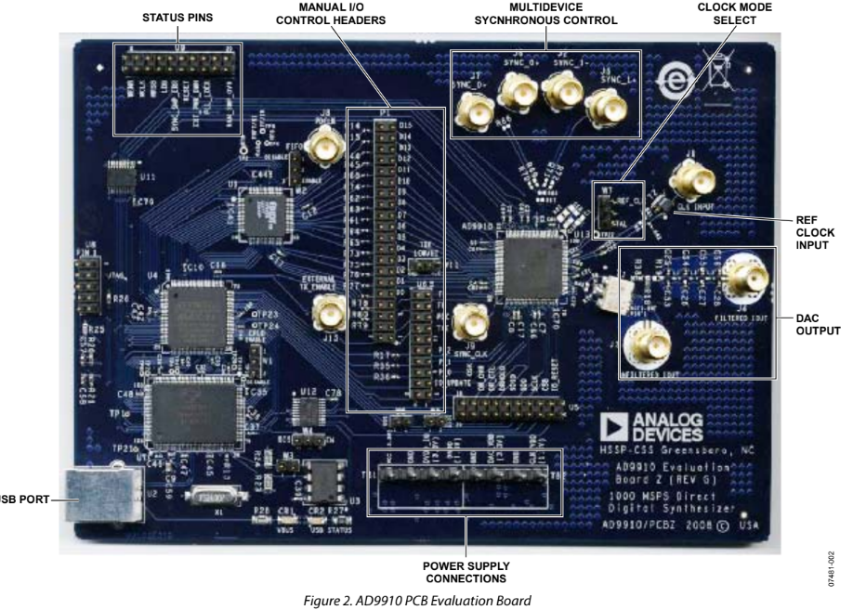

* + Description
    - Evaluation Board for 1 GSPS DDS with 14-Bit DAC

### Features

* + - Full-featured evaluation board for the AD9910
    - PC evaluation software for control and measurement of the

AD9910

* + - USB interface
    - Graphic user interface (GUI) software with frequency sweep
    - Factory tested and ready to use

### Basic Diagram

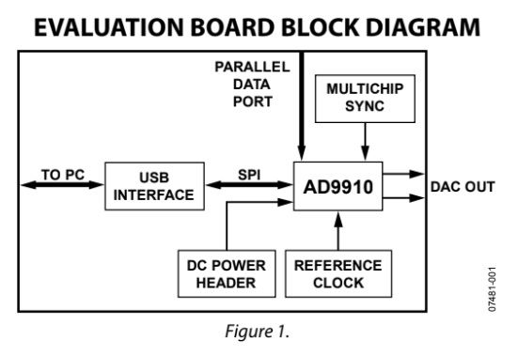

### Connectors and Biasing

|  |  |  |  |
| --- | --- | --- | --- |
| **Connector** | **Pin No.** | **Label** | **Voltage (V)** |
| TB1 | 1 | VCC_USB | 3.3 |
| TB1 | 2 | GND | 0 |
| TB1 | 3 | DVDD_IO | 3.3 |
| TB1 | 4 | DVDD | 1.8 |
| TB2 | 1, 3 | GND | 0 |
| TB2 | 2 | DAC_VDD | 3.3 |
| TB2 | 4 | CLK_VDD | 1.8 |

### Clock Oscillator Option

* + - To enable the crystal mode
      * Switch the jumper, W7 to the XTAL mode.
      * Remove C51 and 52. Place 0 (zero) Ω resistors at R4 and R11 on the backside of the board.
      * The crystal oscillates at 25 MHz.

### Jumpers

* + - To enable different modes of communication

|  |  |
| --- | --- |
| Mode | Settings |
| PC Control,  USB Port | Set Jumper W1 and Jumper W2 to enable.  Set Jumper W4 to enable.  Place a jumper on W5, W6, and W3. |
| External  Control | Set Jumper W1and Jumper W2 to disable.  Set Jumper W4 to disable.  Remove the jumper on W5, W6, and W3. |

* + - * Jumper W1, W2, and W4 enable the USB circuitry to control the AD9910.
      * Jumper W3 controls the EEPROM, used in starting up the USB
      * Jumper W5 and W6 control Signal SDO and Signal SDIO to and from the AD9910.

### Evaluation Board Layout

* + - Manual I/O Control Headers
      * Communication interface for the AD9910 when the part is under the command of an external controller
      * See Table 3 for correct jumper settings.
    - Multidevice Synchronous Control
      * Set up the AD9910 for multidevice synchronous operation.
    - DAC Output
      * Represents filtered or unfiltered (default) output of the DAC
    - Clock Mode Select
      * Controls whether the reference clock source is a 20 MHz to 30 MHz crystal, or is from an external signal generator.
      * A 25 MHz crystal is provided on the underside of the AD9910 evaluation board. (see Clock Oscillator Option)
    - Ref Clock Input
      * For the external reference clock signal
    - Power Supply Connections
      * TB1 and TB2 provide all necessary supply voltages (see Connectors and Biasing)
    - USB Port
      * When under PC control, the communication is via this port

### 

# Theory

## 

## **Reference**

* + Direct Digital Synthesis
    - Analog Devices AD9912 User Manual, *Analog Devices*, 2010.
    - Paul Kern (July 2007). "Direct digital synthesis enables digital PLLs" [(PDF)](https://drive.google.com/file/d/1IFn1tOFzfQulK9GZscALRpb8Tc8-3Wrh/view?usp=sharing). RFDesign.
  + Phase Locked Loop

## **DDS (Direct Digital Synthesis)**

* + Introduction
    - Direct Digital Synthesis(DDS) is a method employed by frequency synthesizers
    - Used for creating arbitrary waveforms from a single, fixed-frequency reference clock
    - Main usages are
      * Signal generation
      * Local oscillators
      * Function generators, mixers, modulators
  + Composition
    - Frequency reference
      * Crystal or Surface Acoustic Wave (SAW)
      * Provides the clock to the NCO
    - Numerically Controlled Oscillator (NCO)
      * Produces at its output a discrete-time, quantized version of the desired output waveform
        + Whose period is controlled by the digital word
    - Digital-to-Analog Converter (DAC)

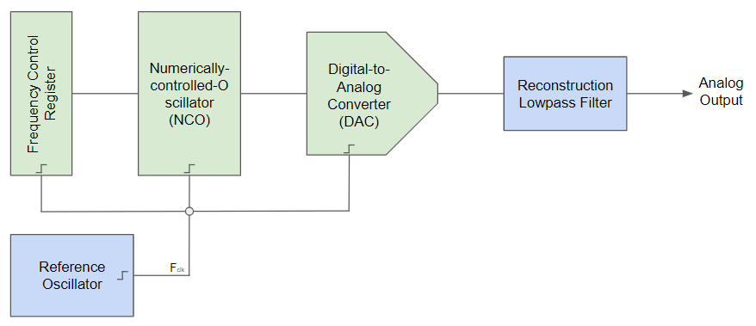

* + Performance
    - Advantages
      * Improved phase noise
      * Need only an external clock to generate simple sine waves
      * Precise control of the output phase across frequency switching transitions
    - Disadvantages
      * Spurious responses due to truncation effects in the NCO
      * Higher noise floor at large frequency offsets due to the DAC
  + How to make a sine wave

## **PLL (Phase Locked Loop)**

# Procedure

## Evaluation Board software

* + Installing the software

1. Log into your PC system with administrative privileges.

2. Uninstall any previous versions of the AD9910 evaluation software from your PC system.

3. Run the setup.exe file located in the Software folder and follow the AD9910 evaluation software onscreen installation instructions.

* + Installing the driver
  + Reference input
    - Accepts a single-ended reference input as SYSCLK
    - Divided into 2 ports
      * Making them differential inputs artificially

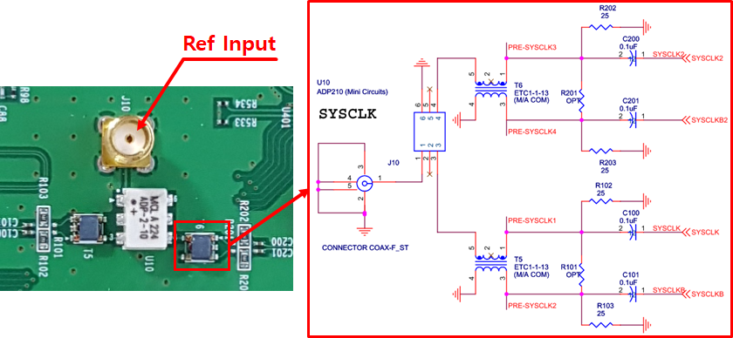

* + Power ports
    - Power ports from eval board are integrated onboard
    - No power ports are needed
      * Accepts a DC input only

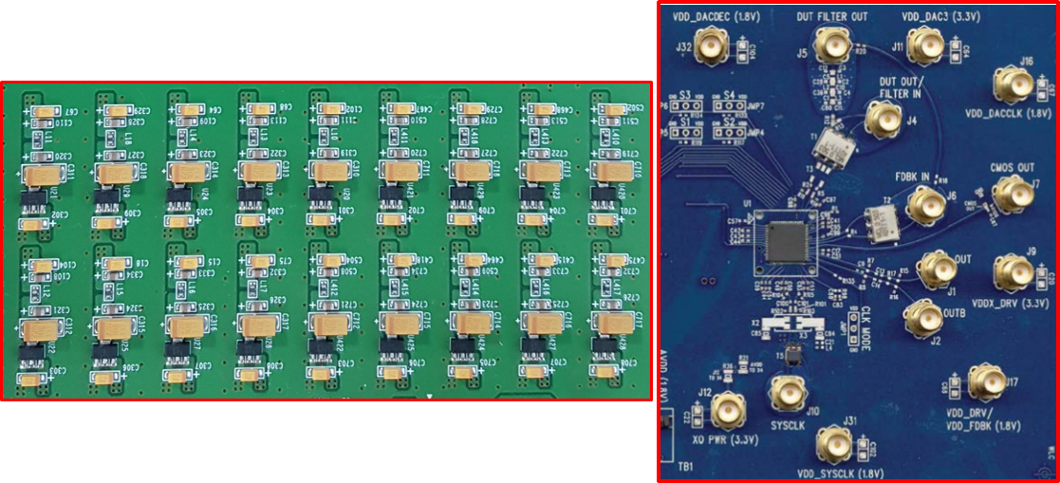

* + Output ports
    - DAC Output with low-pass filter
    - Differential Output

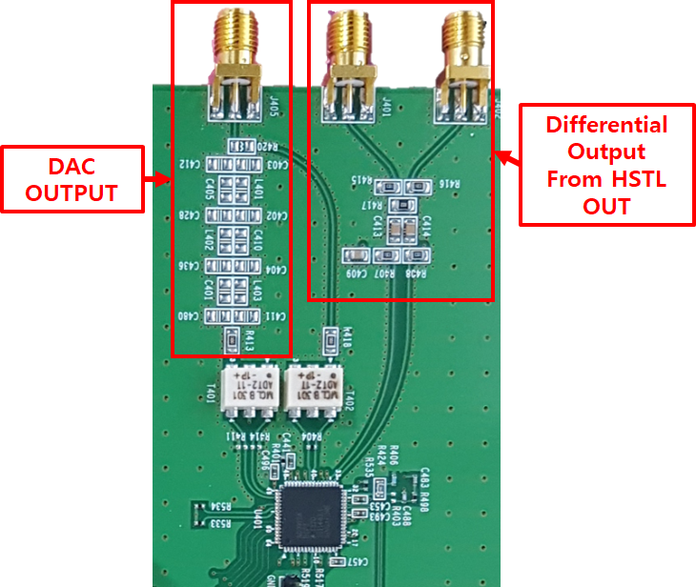

## 

## Circuit

* + Pins layout

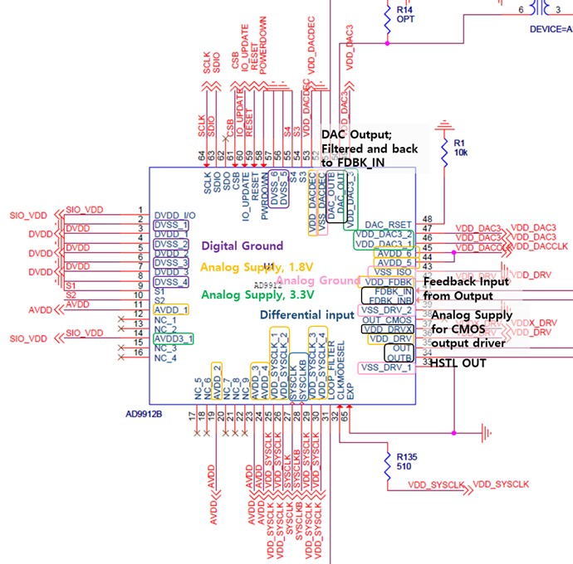

* + Start-up configuration pins
    - S2 to S4 pins are set to 1
    - Only S1 is used to read and write

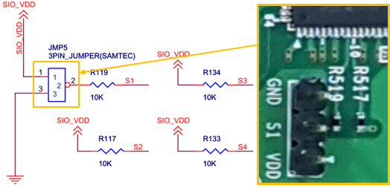

* + General input pins
    - P2 and P3 pins accept general inputs to operate normally
    - P3 pins use IO_UPDATE pins only

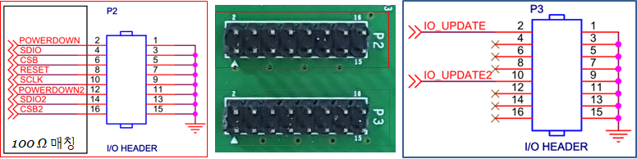

## 

# Log

### YYYY.MM.DD

* Goal
* Progress
* To do

### 2020.02.04

* **Goal**
  + Properly run the evaluation software
* **Progress**
  + Pin connection

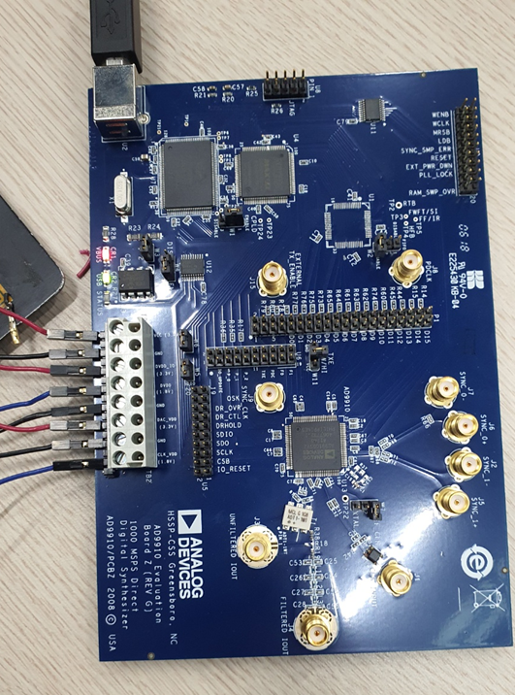

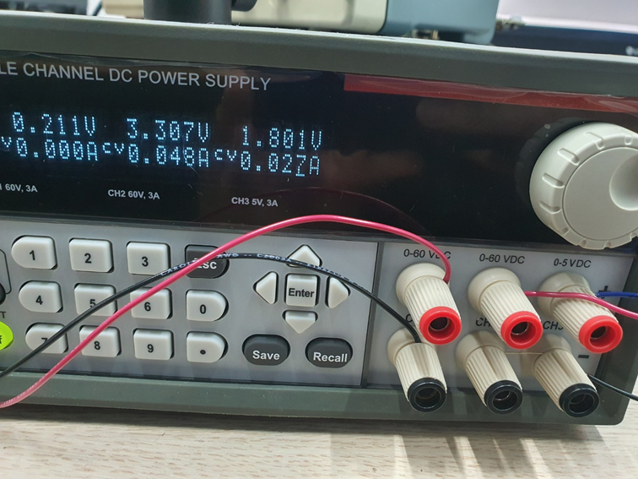

* + Software

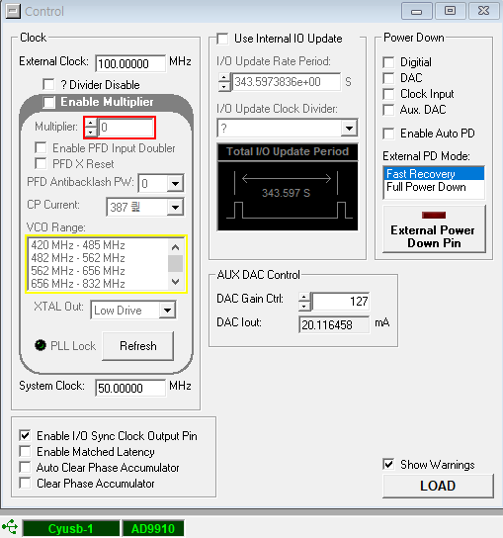

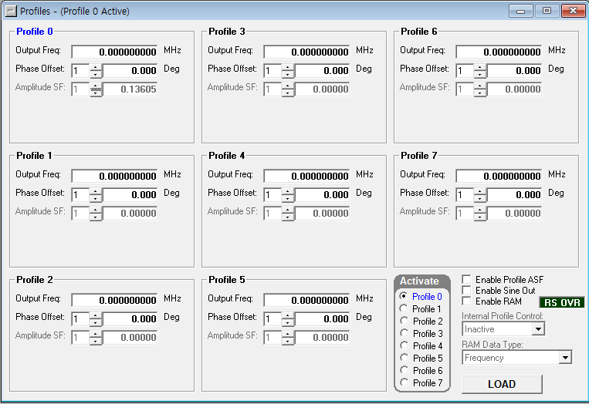

* To do
  + Read the output frequency

### 2020.02.06

* Goal
  + Read the output frequency
* Progress
  + Reading failure
    - Set the frequency to 34 MHz in the profile

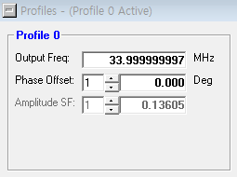

* + - A peak is detected at around 50 MHz (System clock)

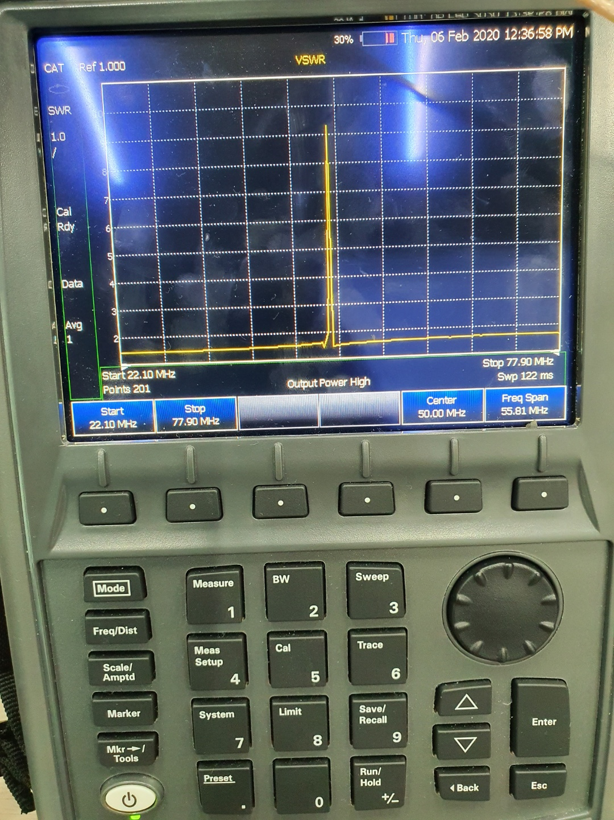

* Requested help with this board to TH Kim.
  + Resolved by myself before his response
* Found out the default mode is “External reference freq needed” and this is way simpler. FYI: Clock Oscillator Option
  + So I connected the 100 MHz, 0.1 Vpp input from SG384 to the ref (J1)
* And the result
  + When I triggered 25 MHz output

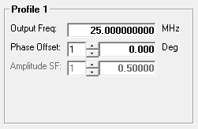

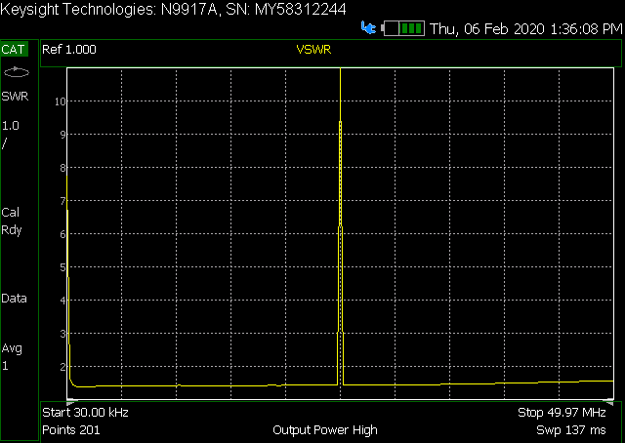

* + When I triggered 33 MHz output

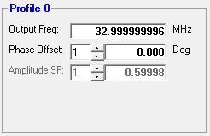

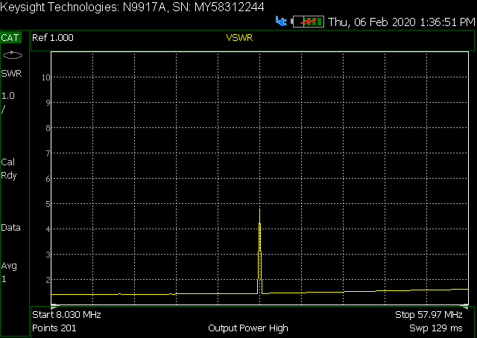

* To do
  + Study more about the AD9910 and hold this project until AD9912 works fine

### 2020.02.12

* Goal
  + Understand how to tune the frequency
* Progress
  + Bits description (AD9910, pp.49)

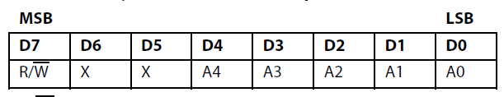

* While AD9912 has 16 bits of ADDR



* While AD9912 has 48 bits to tune the freq.
* Writing Frequency Tuning
* Amplitude Scale Factor Register (ASF) (pp. 58)

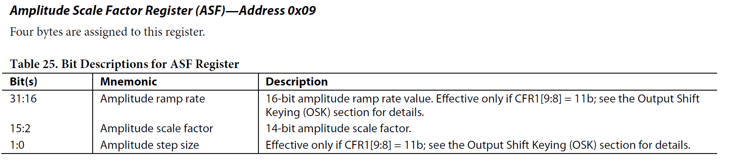

* To do
  + Write a test code

### 2020.02.14

* Goal
  + Write a test code
* Progress
  + Need to assign pins
    - FPGA for AD9912

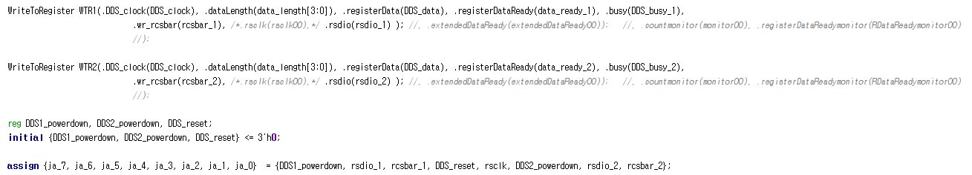

* SDIO1, SDIO2 pins are assigned
  + ja6, ja0 each
* We are gonna use single tone mode
  + With SDIO SPI communication



* To do
  + Build a test python code

### 2020.02.20

* Goal
  + Build a test python Code
* Progress
  + How to write

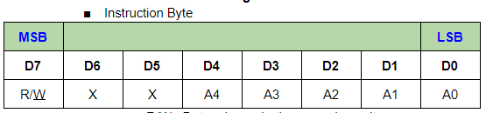

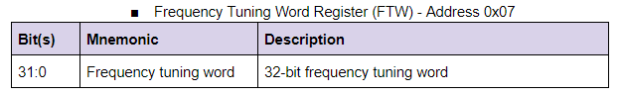

* Which means
  + 1 byte for the instruction
    - 0XX00111 (0x07) is the FTW instruction
  + 4 bytes for tuning the frequency
* Python code
  + File path: **q:\qc_user\Users\thkim\Arty_S7\DDS\v1_01\python\AD9910_V0_01.py**
  + **make_header_string(register_address, direction=’W’)**
    - It doesn’t need W1W0 like in AD9912

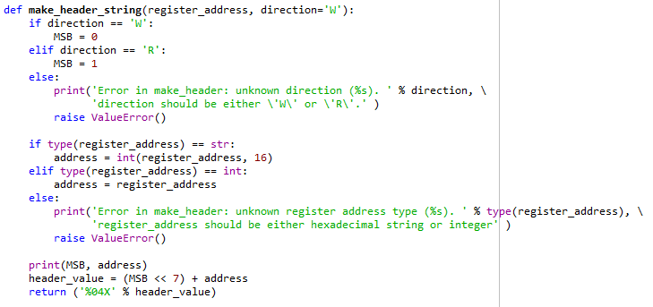

* + **FTW_Hz (freq)**
    - It generates the frequency tuning words in hexadecimal string
    - AD9912 required
      * 2 bytes of the instruction word(4 characters in hexa)
      * 48/8 = 6 bytes of the FTW_body (12 characters of hexa)
    - While AD9910
      * 1 bytes of the instruction word (2 characters in hexa: 0x07)
      * 32/8 = 4 bytes of the FTW_body (8 characters in hexa)

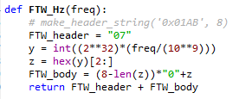

* If len(z) less than 8, then
  + it fills “0” in front of the z

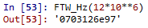

* To do
  + Test the code

### 2020.02.21

* Goal
  + Test the code
* Progress
  + No success

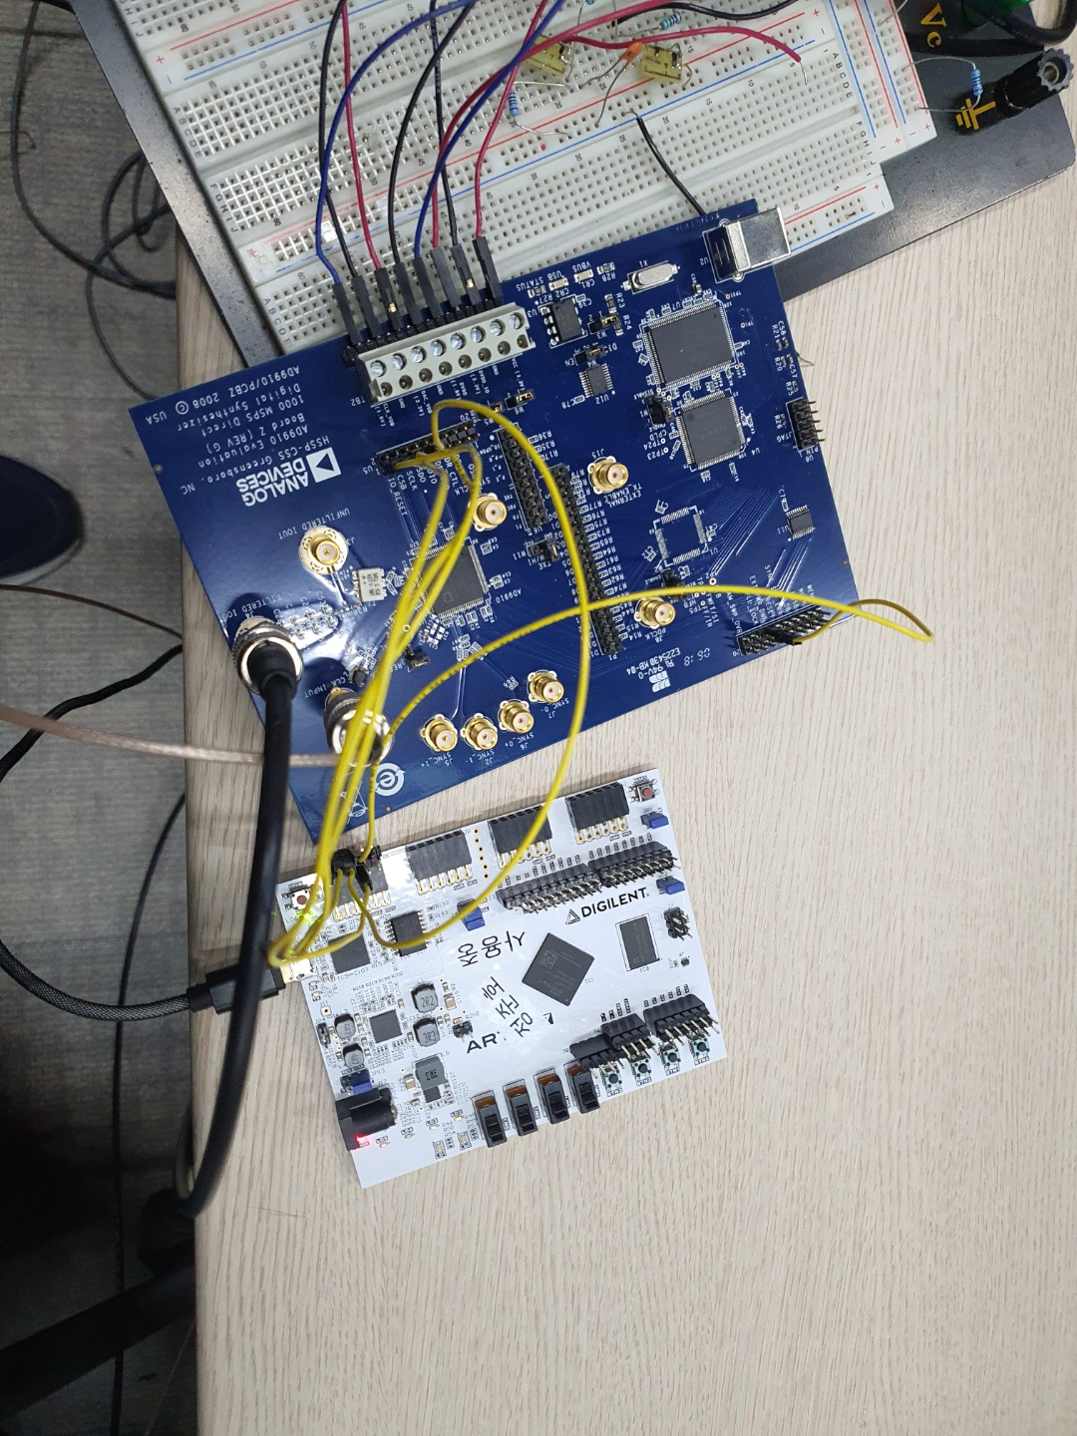

* + - * I wired them SDIO, CS, etc…
      * And changed the jumper
      * Need more tests but I couldn’t access to the board.
* To do
  + Figure out what caused the problem

### 2020.02.25

* Goal
  + Figure out what causes the problem
* Progress
  + Found something that I can get a hint
    - <https://github.com/GRA-AFCH/DDS-AD9910-Arduino-Shield/blob/master/DDS-AD9910-Arduino-Shield/ad9910.cpp>
    - In this example
      * **Uses a Single_Tone operation**

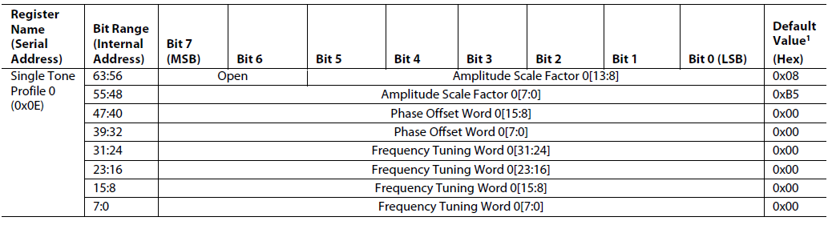

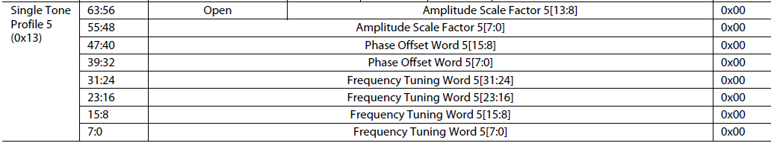

* + - * GPIO_PIN_SET => 1
      * GPIO_PIN_RESET => 0
      * Which means HAL_GPIO_WritePin(DDS_SPI_CS_GPIO_PORT, DDS_SPI_CS_PIN, GPIO_PIN_SET) => chip select goes to 1.

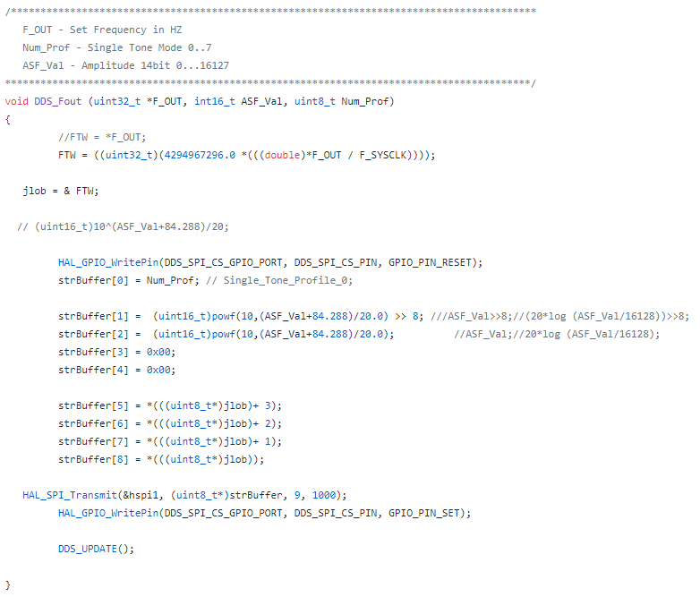

* + - Summary
      * First it makes the CS_PIN 0.
      * Then defining the strBuffers
        + strBuffer (Profile ADDRESS)

0 ~ 7.

* + - * + strBuffer[1:2] : Amplitude tuning
        + strBuffer[3:4] : Phase tuning -> 0
        + strBuffer[5:8] : Frequency tuning
      * SPI transmitting

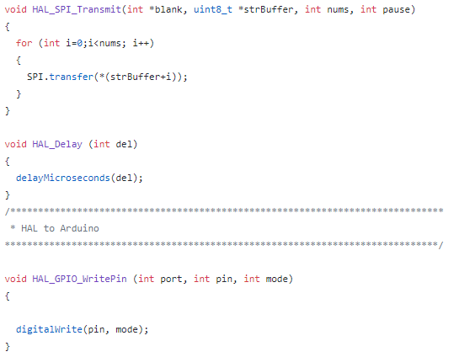

* + - * + A string with 9 bytes transmitted
      * Finally, CS_PIN goes to 1.
      * DDS_UPDATE()

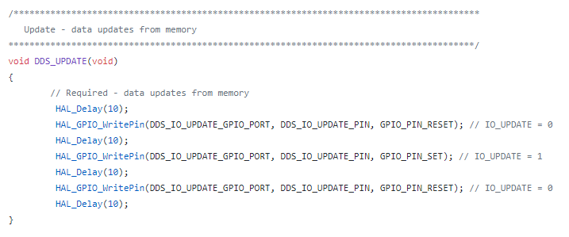

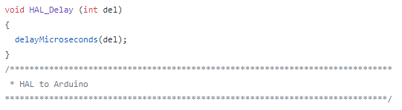

* + - * + Waits for 10 microseconds
        + IO_UPDATE => 0
        + Waits for 10 microseconds
        + IO_UPDATE => 1
        + Waits for 10 microseconds
        + IO_UPDATE => 0
        + Waits for 10 microseconds
      * On more upper level

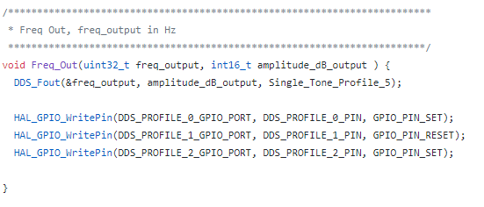

* + - * + where **Single_Tone_Profile_5** = 0x13
        + The profile pin goes to 101

Makes the output freq as programmed in the profile 5?

* + Says 5 pins to operatie it properly
    - SDIO
    - SCLK
    - IO_RESET
    - CS
    - I/O_UPDATE
* To do
  + Test test test

### 2020.03.16

* Goal
  + Test the input TTL with an oscillator
* Progress
  + ARTY S7-50
    - PMOD

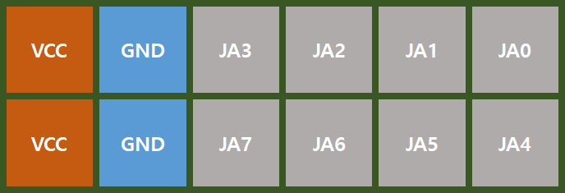

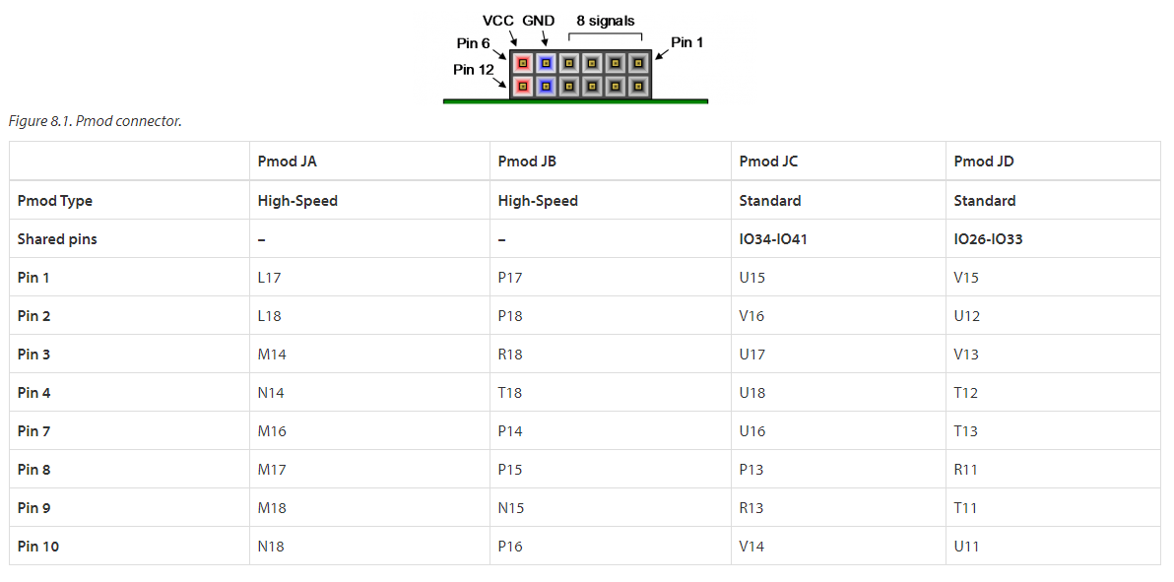

* While in the program
  + I connected the pins to

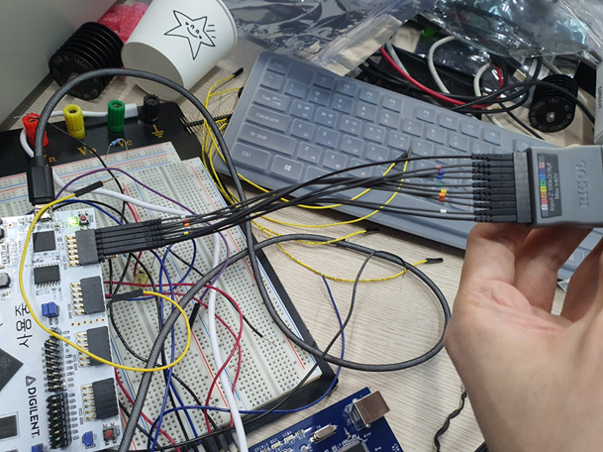

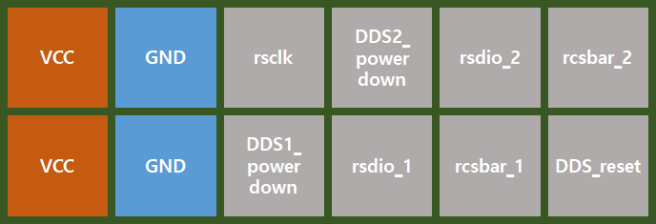

* + Now the result

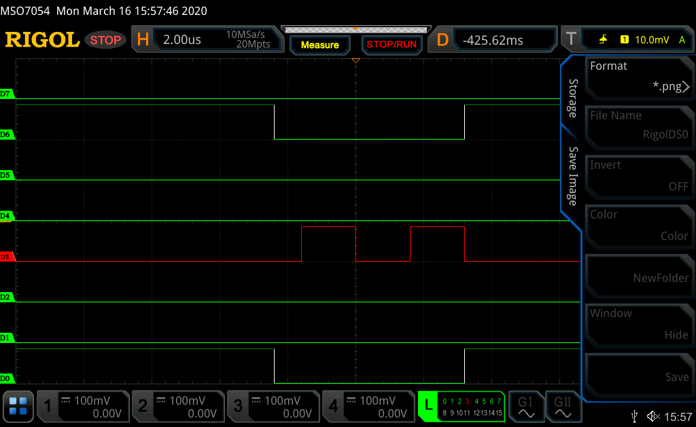

* To do
  + Maybe decoding??